Material from The Session
Tune 98: The Sally Gardens reel - Also known as Na Gairdíní Saileacha, Na Garranta Sailí, The Salley Gardens, The Sally Garden, Sally Garden’s, Sally Gardner’s, Sally’s Garden.

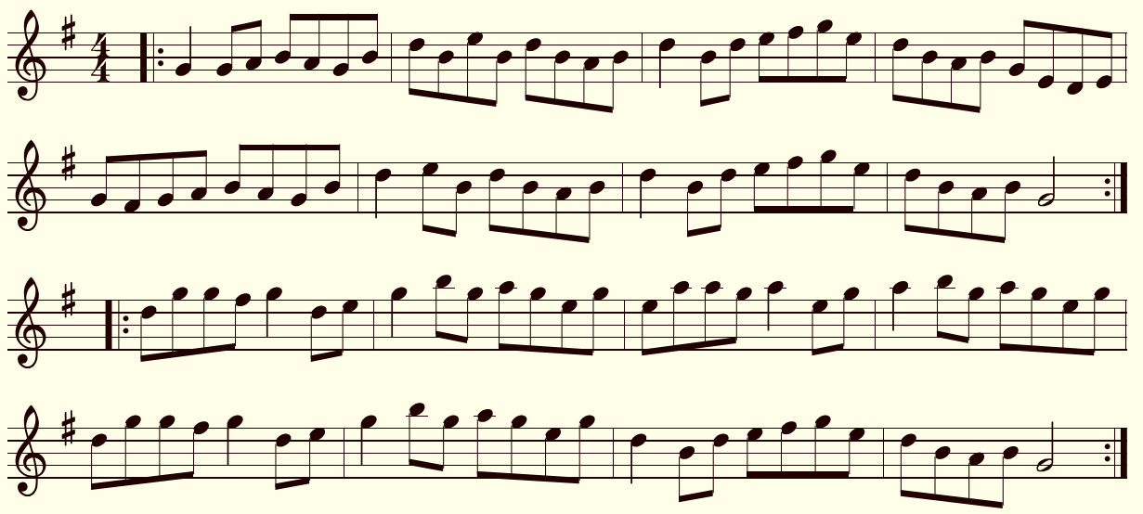

Tune 1314 : Down By The Sally Gardens reel
Also known as An Traigh Mughdhorna, Down By The Salley Gardens, Gort Na Saileán, The Maid Of Moorlough Shore, The Maid Of Mourne Shore, The Maid Of The Mourne Shore, The Maids Of Mourne Shore, The Maids Of The Mountain Shore, The Mourne Shore.

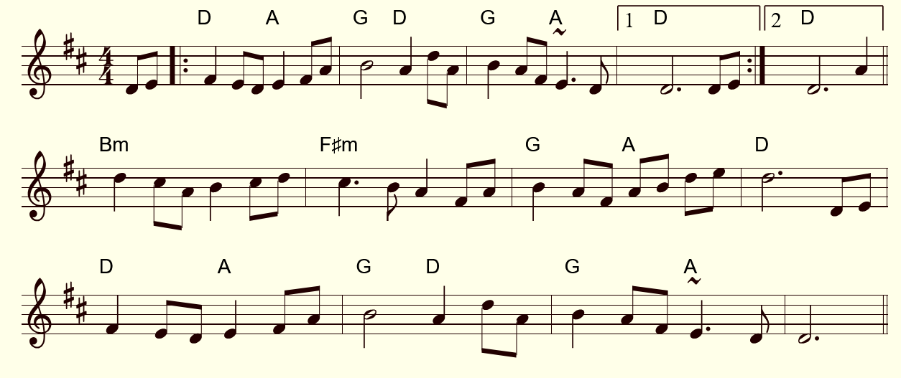

Tune 25639 : Gáirdín Na Saileach Jig (Also known as Down By The Sally Gardens)
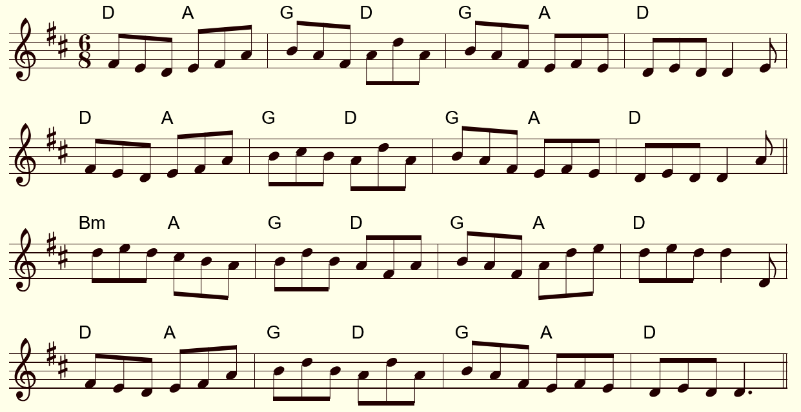

User’s comment : This jig was played at a session this week. It followed the song “Down by the Salley Gardens”, aka the Garden of Willows (genus Salix). It’s a perfect segue into a set of jigs. The suggested chords worked better at the slower tempo. (enchainement, better in slower tempo).

